String is a data type in java script

.slice( )

it can be used to extract a certain part of string

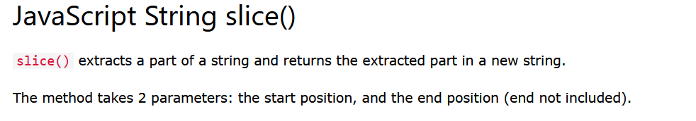

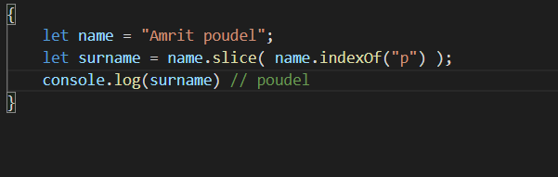

If the end position is not included than whole string from starting position gets sliced

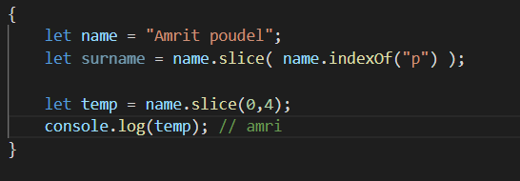

Also character of end position is not included

**In javaScript string we counted from backward than we would be using negative numbers for index**

like this

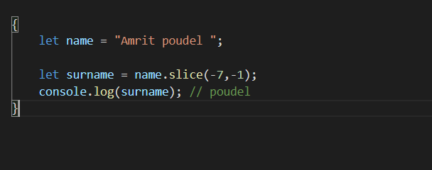

Seems very odd, feels like I wont be using it

So we have two other methods, that are just like .slice( )

But they don’t take the negative numbers

.substring( )

It is just like .slice( ) but it do not take the negative numbers

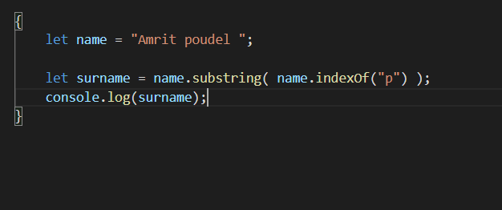

If end position is not mentioned than whole string after starting position is returned

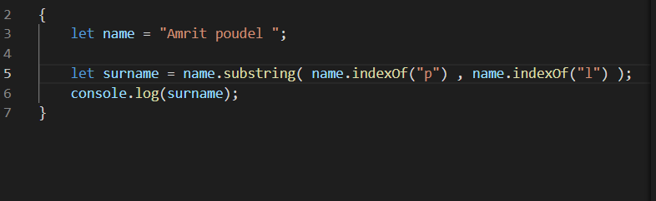

**character at the last index is not included**

.substr( )

it also do not take the negative numbers

first argument is starting position

**second argument is length from the starting position**

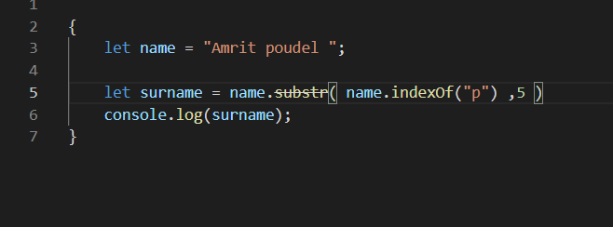

Just like in above two if end position isnot mentioned then

whole string after starting position is returned

.replace( )

It replaces the first arg. string with second arg. string and return the new string

It doesnot change the original string

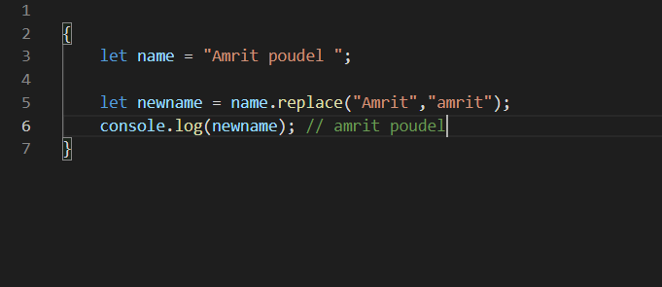

Also it only replaces the first match

**We often use this method with regular expression to replace certain string within big string**

.toUpperCase ( ) and .toLowerCase( ), converts the given string to uppercase and lowercase

.concat( )

It joins the two string and form a new string

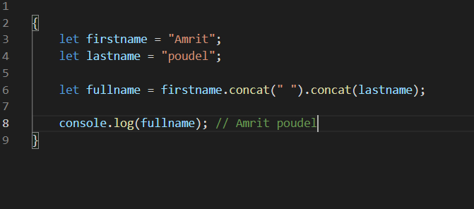

.trim ( )

Very useful method, since sometimes extra whitespace around string are annoying

It removes the whitespaces from both sides of string

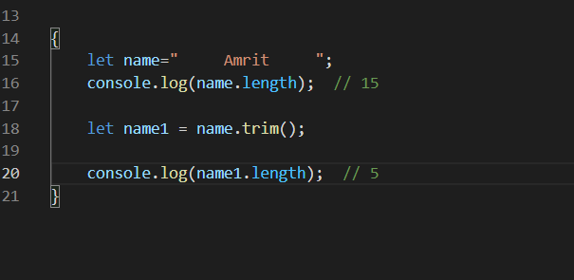

.charAt( )

returns the character at the given index number

.charCodeAt( )

returns the Unicode of the character at the given index number